Building BCH – Aware websites

BCH AJAX Plug-In Users’ Guide

January 2013

This manual version is based on the actual deployed version of BCH Ajax Plug-in, as of the date of publication. All minor updates and changes will be published in BCH Virtual Learning Environment, http://moodle.bch.cbd.int, under the course “Developing websites using AJAX plugin”, and its associated discussions and news forums.
.

Contents
List of Figures 3
List of Tables 3
List of Acronyms and Abbreviations 4
1. Introduction to the Manual 5
2. The BCH AJAX Plug-In 6
2.1. Overview 6
2.2. Compatibility 6
2.3. Maintenance 6
2.4. Integration 6
2.5. Ajax simple demo application 7
2.6. Customization 9
2.6.1. Document Type 10
2.6.2. Country 12
2.6.3. Language 12
3. Embedding the JavaScript and AJAX Plug-In 15
3.1. Embedding the JavaScript 15
3.2. Integrating the AJAX Plug-In 16
3.3. Usage of wildcards and combined parameters. 19
3.4. Search within results 21
3.5. Comments on searching reference records 21
Annex 1. ISO 3166 Country codes 22

List of Figures
Figure 1. Sample of an AJAX Plug-In. 6
Figure 2. AJAX Plug-In integrated into a basic web page. 7
Figure 3 display of previous html page 7
Figure 4 Ajax demo application 8
Figure 5 Generated AJAX script and retrieved records 9
Figure 6. Parameters used in the BCH AJAX Plug-In. 9
Figure 7 Selecting a National record type 11
Figure 8 Selecting a Reference record type 11
Figure 9 Selecting country 12
Figure 10. The “Select Language” Button, BCH Management Centre 13
Figure 11. “Additional Languages” drop down list from BCH Management Centre. 13
Figure 12. Registering Information with Official UN Language and another additional Language. 14
Figure 13 Selecting language 15
Figure 14. Sample JavaScript. 15
Figure 15. Embedding the JavaScript within the head tags. 15
Figure 16. Embedding the JavaScript within the body section. 15
Figure 17. JavaScript written in an external file. 16
Figure 18. AJAX Plug-In to be integrated. 16
Figure 19. Country profile of India generated from the BCH Portal. 17
Figure 20. Types of document available in India. 17
Figure 21 using the Ajax demo app to generate and run an Ajax script 19
Figure 22 Search within results feature 21

List of Tables
Table 1 Value of the type of information to be displayed – national records 10
Table 2 Value of the type of information to be displayed – reference records 10
Table 3 ISO 3166 two-letter country code. 22

List of Acronyms and Abbreviations

AJAX | Asynchronous JavaScript And XML
BCH | Biosafety Clearing-House
GEF | Global Environment Facility
nBCH | National BCH
SCBD | Secretariat of the Convention on Biodiversity
UNEP | United Nations Environment Programme

Introduction to the Manual

What you will learn in this manual:
This training manual describes in detail the guidelines about using Ajax Plug-in to develop and maintain a National BCH application

Context:
The UNEP-GEF Project for Capacity Building for Effective Participation in the Biosafety Clearing-House (BCH-I), in collaboration with the Secretariat of the Convention on Biological Diversity (SCBD), prepared a modular training package aimed at providing a practical “how-to” guide for countries to assist them in learning, understanding, using, and setting up national access to the BCH. The training package was later updated within the UNEP-GEF Project for Continued Enhancement of Capacity Building for Effective Participation in the BCH (BCH-II). It was designed to be flexible and is tailored to meet the diverse needs of different countries, allowing them to select those tools that are most useful to their situation, needs and priorities. The training package is divided into several manuals, each addressing one element of the BCH..
Audience:
This manual is designed to provide guidance to administrators and developers of any kind of websites that wish to easily include information from the BCH in them.
Purpose:
This manual describes in detail the guidelines and step by step process about using AJAX Plug-In for displaying BCH information in existing websites.

The BCH AJAX Plug-In

Overview

The Secretariat to the Convention on Biological Diversity (SCBD) has developed an application tool called “BCH AJAX Plug-in” which is ready to be used by any web developer, (and particularly the countries when building websites that wish to include BCH-registered information). It is a lightweight JavaScript plugin based on AJAX technology that can be easily integrated to any website to allow dynamic display of information from the BCH Central Portal.
The use of the BCH AJAX Plug-In does not require any specific IT knowledge. The Plug-In works on all server platforms and does not require any software installation. All required files are located on the BCH Central Portal and maintained by the Secretariat.
The BCH AJAX Plug-In is a client side application. The connection to the BCH Central Portal is made directly by the client (end-user).

Compatibility
The Secretariat fully supports the following browsers versions:
- Internet Explorer 8+
- Mozilla Firefox 3.5+
- Google Chrome
- Safari 4+
It must also be noted that support for JavaScript must be enabled for the BCH AJAX Plug-In to work.

Maintenance
The BCH AJAX Plug-In is fully supported and maintained by the Secretariat. As all files are located on the BCH Central Portal, there is no need for maintenance at the local level.

Integration
The BCH AJAX Plug-In has been designed to make its integration to any website as simple as possible. It can be integrated to any webpage by simply adding the following lines of HTML. Figure 1 shows a usage example of this plugin, to display national focal points from Canada, in English:

<script type="text/javascript" charset="utf-8"
src="http://bch.biodiv.org/centralportal/ui/offsite/bch-offsite.js"></script>
<script type="text/javascript" charset="utf-8" >
GenerateRecords("focalPoint", "ca", "en");</script>
Figure 1. Sample of an AJAX Plug-In.
Figure 2 is a very basic HTML page integrating the BCH AJAX Plug-In.

<html>
<body>
<h1>National Focal Points</div>
<script type="text/javascript" charset="utf-8"
src="http://bch.biodiv.org/centralportal/ui/offsite/bch-offsite.js"></script>
<script type="text/javascript" charset="utf-8" >
GenerateRecords("focalPoint", "ca", "en");</script>

</body
</html>

Figure 2. AJAX Plug-In integrated into a basic web page.
And the next figure shows the results of displaying this html page:

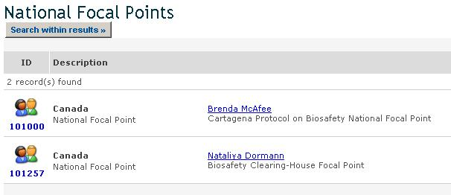
Figure 3 display of previous html page

Ajax simple demo application
In order to help potential users to understand how to use and integrate the BCH Ajax plug in html webpages, a simple demo website has been developed. It is freely available at http://bch.cbd.int/help/topics/ajaxdemo/

Once started, the website looks initially like Figure 4.

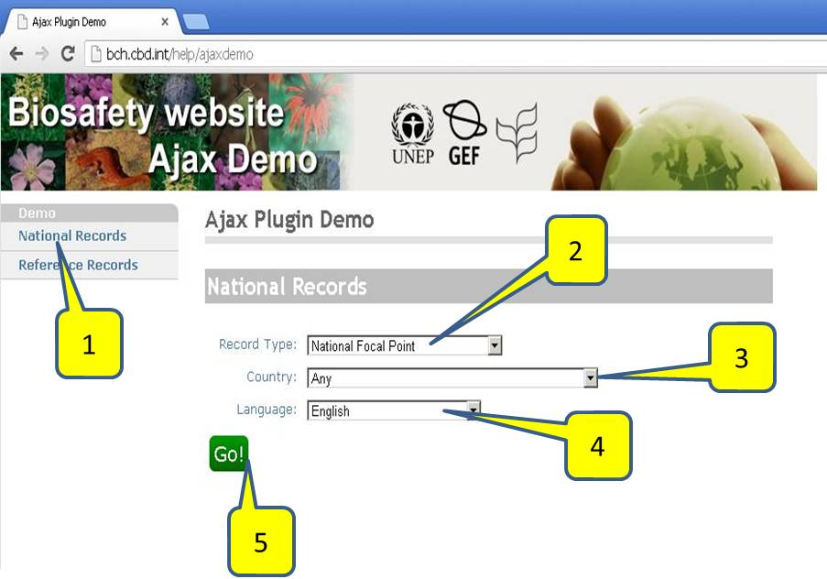
Figure 4 Ajax demo application
The following controls are available in the main screen:
- Select national or reference records
- Select type of record or “Any” (see Note)
- Select country or “Any” for all countries (see Note)
- Select record language
- Press to see the query and its results

NOTE: “Any” cannot be used at the same time for record type and country

Once the type of records, country and languages have been selected, clicking on “Go” will generate and execute the script. The generated script will be showed in a text box, and the records retrieved will be displayed below.

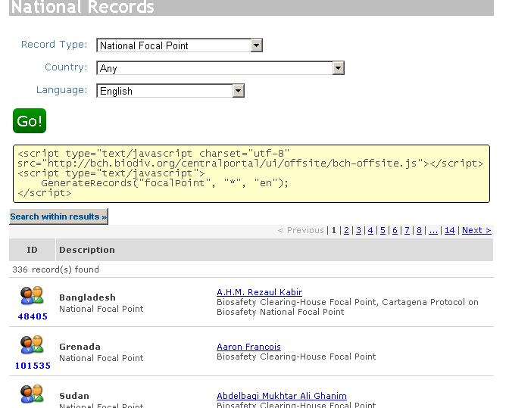

Figure 5 Generated AJAX script and retrieved records

Customization
The BCH AJAX Plug-In can be easily customized to show any specific type of BCH national information for any country, or BCH reference information. To do this, the parameters of the GenerateRecords (Figure 6) method must be specified.

function GenerateRecords(documentType, country, language);

Figure 6. Parameters used in the BCH AJAX Plug-In.

Document Type
This parameter specifies what type of BCH national information to display. Table 1 and Table 2 show the valid values for this parameter:

Type of information to display  National Records | Value
National Focal Point | focalPoint
Competent National Authority | Authority
National Database | nationalDatabase
Law, Regulation or Guideline | Law
Agreement or Arrangement | Agreement
Decision on LMO | decisionUnderAIA
Decision on LMO-FFP | decisionUnderA11
Other Decision | Decision
Biosafety Expert | biosafetyExpert
Report on Assignment | biosafetyExpertAssignmentReport
Capacity Building Opportunity | capacityBuildingOpportunity
Capacity Building Project | capacityBuildingProject
Capacity Building Need or Priority | countryNeedsAndPriorities
Risk Assessment | riskAssessment
Second National Report in the implementation of CPB | nationalreport2
Table 1 Value of the type of information to be displayed – national records

Type of information to display  Reference Records  NOTE: Country code must be set to "*" | Value
BCH news | news
Biosafety Information Resource Centre | birc
Organism Registry | organism
Gene and DNA Sequence Registry | dnasequence
Living Modified Organism (LMO) Registry | modifiedorganism
Organizations involved in Biosafety Activities | organization
Laboratory for detection and identification of LMOs  (a subset of Organizations) | lmodetectionlaboratory
Table 2 Value of the type of information to be displayed – reference records

Using the Ajax demo application you can select the type of records to search and display, as shown in Figure 7 and Figure 8. If “Any” selected, all types of records from the specified country will be retrieved.
NOTE: “Any” cannot be used at the same time for record type and country

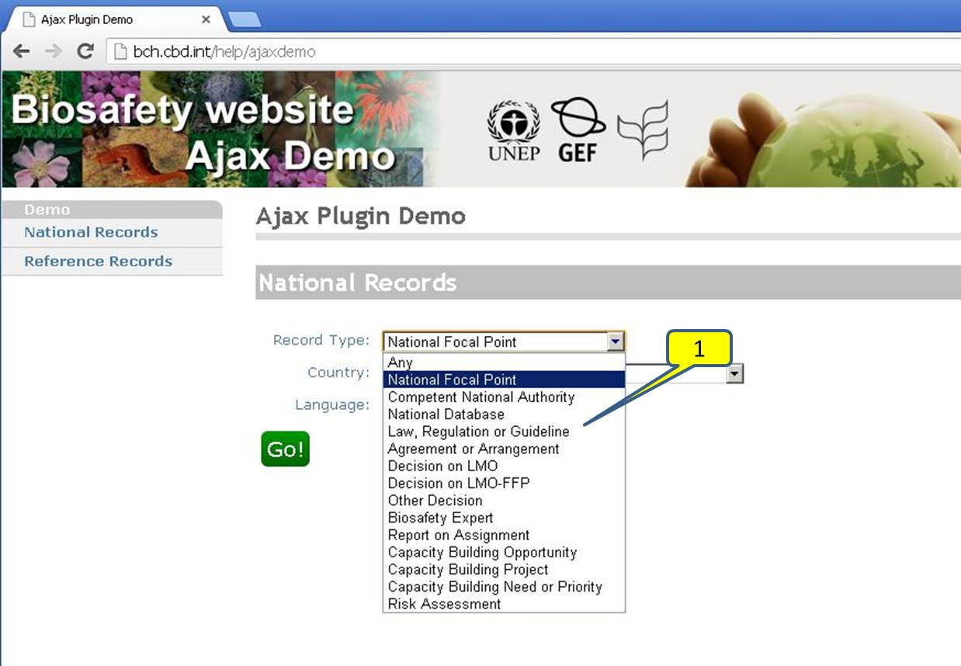
Figure 7 Selecting a National record type

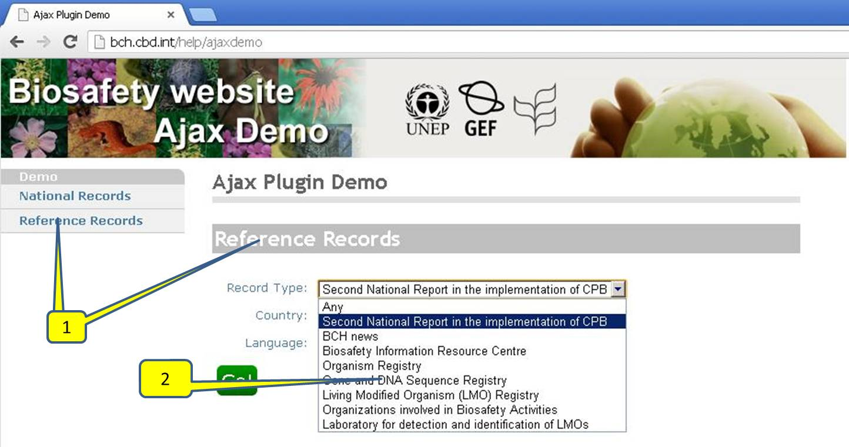
Figure 8 Selecting a Reference record type

Country
The parameter specifies the country for which the information is displayed. The BCH AJAX Plug-In uses 2-letter ISO 3166 country codes. Annex 1 contains a list of such codes, which can also be retrieved at any moment from
http://www.iso.org/iso/country_codes/iso_3166_code_lists/country_names_and_code_elements.htm
Using the Ajax demo application you can select the Country which records to search and display, as shown in Figure 9. If “Any” selected, records of the specified type will be retrieved for all countries:
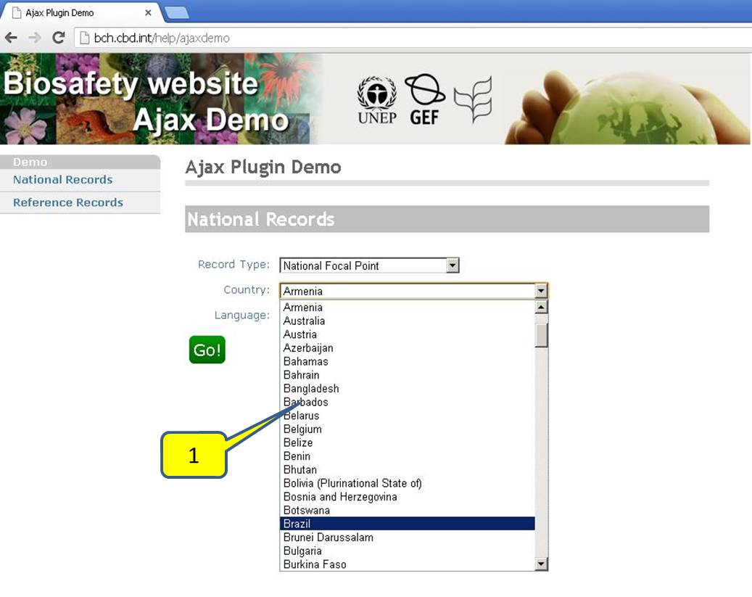
Figure 9 Selecting country
NOTE: “Any” cannot be used at the same time for record type and country

Language
This parameter specifies in which language the information should be displayed. The BCH AJAX Plug-In is not limited to the 6 UN languages. The latest version of BCH Central Portal allows the country-users to select other languages aside from the 6 UN official languages when registering information. At the Management Centre section of the BCH Central Portal, additional language can be selected by clicking on the “Select Languages” button (Figure 10).
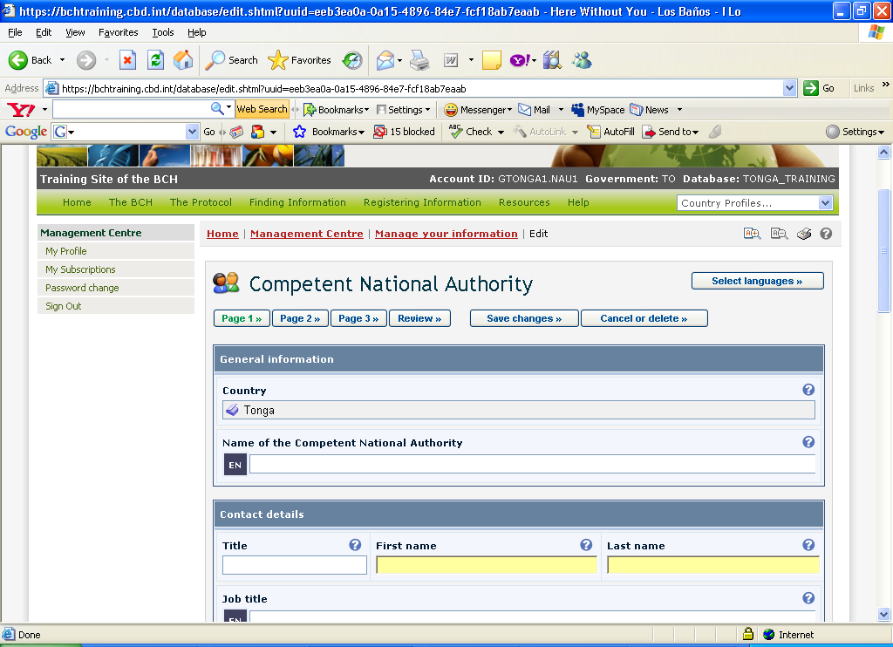
Figure 10. The “Select Language” Button, BCH Management Centre

A drop-down list of additional languages is available and one or more languages can be selected ().

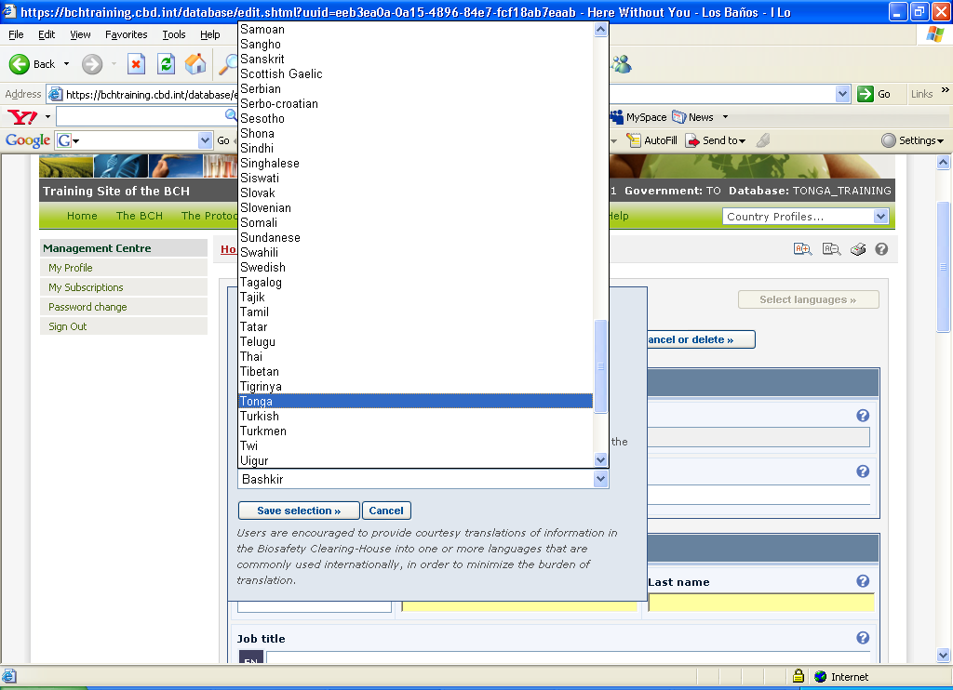

Figure 11. “Additional Languages” drop down list from BCH Management Centre.

After that, the authorized users can register information on the BCH portal in both the UN language(s) of choice and other one(s) (Figure 12).

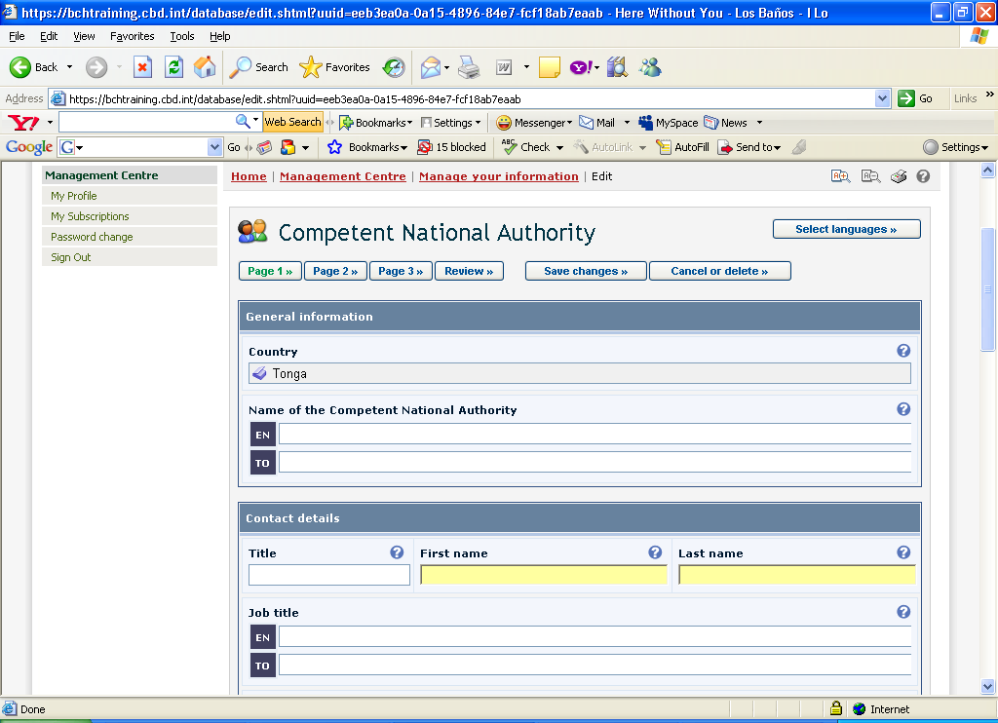
Figure 12. Registering Information with Official UN Language and another additional Language.

The complete list of language codes that can be used for this parameter, can be found at:
http://www.loc.gov/standards/iso639-2/php/English_list.php

Using the Ajax demo application you can select the language, as shown in .
Note that the first rows list the UN official languages.
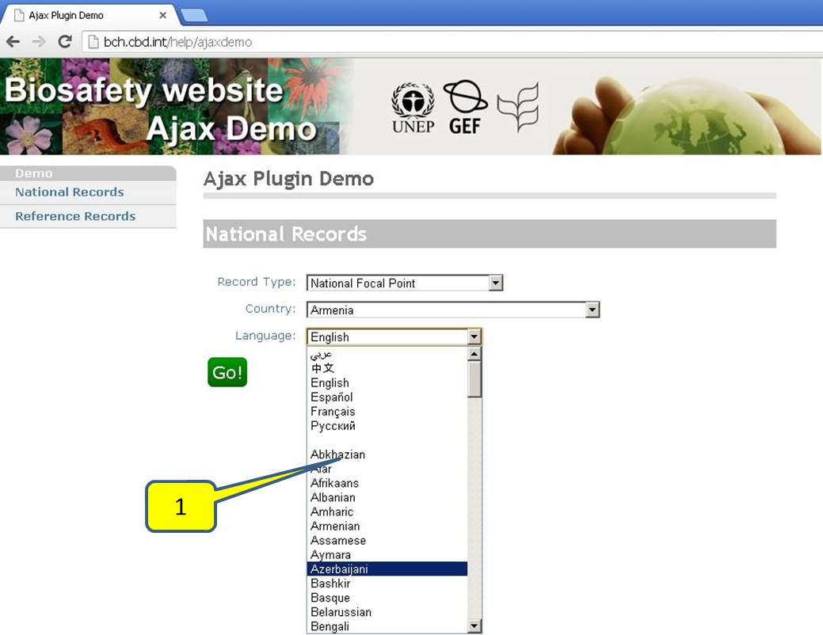

Figure 13 Selecting language

Embedding the JavaScript and AJAX Plug-In

Embedding the JavaScript
What you will learn in this section:

The JavaScript and AJAX Plugin formats.
Where to place the JavaScript and AJAX Plugins

JavaScript is important to make the AJAX Plug-In work. The webpage (regardless of format – html, php, asp, etc.) where your front-end is (where information will be displayed) shall contain the following lines:
<script type="text/javascript" charset="utf-8" src="http://bch.biodiv.org/centralportal/ui/offsite/bch-offsite.js">
</script>

Figure 14. Sample JavaScript.
Now where do we put the JavaScript?

Generally, JavaScript can be placed within the head or body section or can be declared as an external script. If you want the script to be executed when it is called or when a user triggers an event, put the script in the head section.
<html>
<head>
<script type="text/javascript" charset="utf-8" src="http://bch.biodiv.org/centralportal/ui/offsite/bch-offsite.js">
</script>
</head>

Figure 15. Embedding the JavaScript within the head tags.
For JavaScript that needs to be executed immediately while the page loads into the browser, put it in the body section.
<html>
<head>
</head>
<body>
<script type="text/javascript" charset="utf-8" src="http://bch.biodiv.org/centralportal/ui/offsite/bch-offsite.js">
</script>
</body>

Figure 16. Embedding the JavaScript within the body section.

The external script is recommended if you want to run the same JavaScript on several pages without having to write the same script on every page. The JavaScript is written in an external file and saved with a “.js” file extension.
To use the external script, point to the .js file in the "src" attribute of the <script> tag:
<html>
<head>
<script src="external.js"></script>
</head>
<body>
</body>
</html>

Figure 17. JavaScript written in an external file.

Integrating the AJAX Plug-In
After declaring the JavaScript, we are now ready to integrate the following AJAX Plug-In:

<script type="text/javascript" charset="utf-8" >
GenerateRecords("documentType", "countryCode", "language");
</script>

Figure 18. AJAX Plug-In to be integrated.
where “documentType” is the value of the type of information to be displayed (see section 3.6.1, Table 1 and Table 2), “countryCode” is the 2-letter ISO 3166 country code (see section 3.6.2); and “language” is the code which specifies in which language the information should be displayed (see section 3.6.3.)
To illustrate, let us consider the different available documents in India. First, we generate the country profile of India.

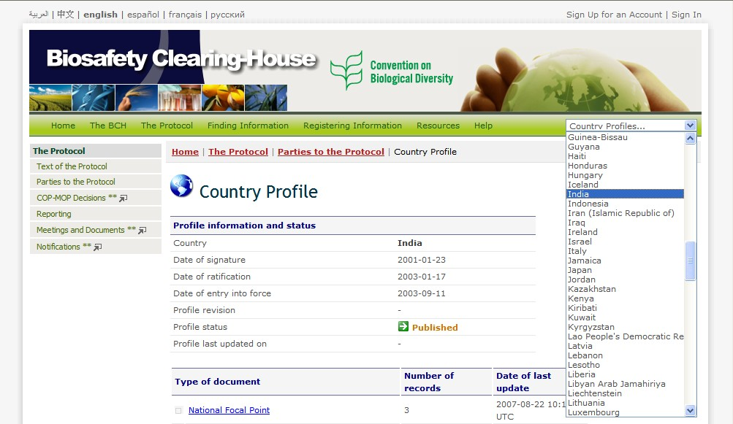
Figure 19. Country profile of India generated from the BCH Portal.
Then, we check for available information on India. Based from the generated page, the types of document available information on India can be seen looking in “country profiles” (Figure 20)

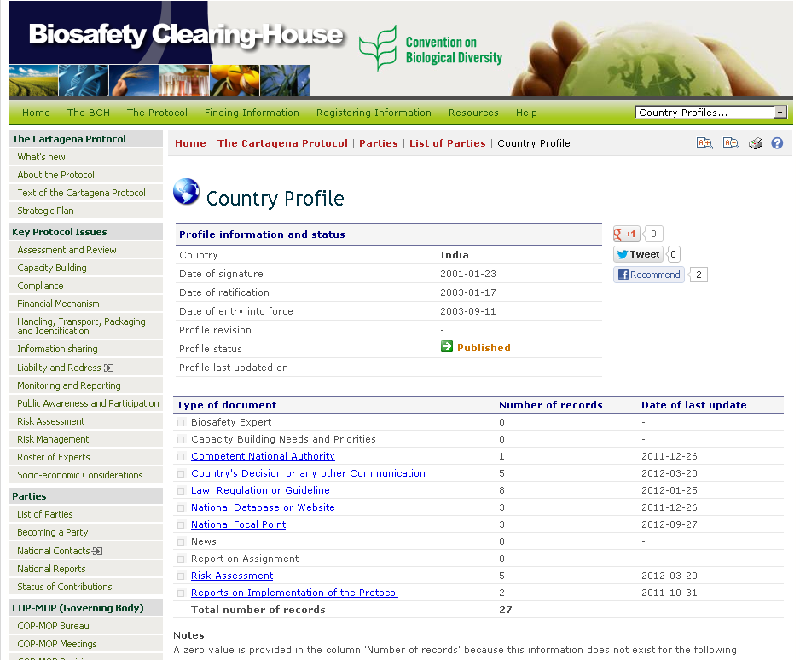
Figure 20. Types of document available in India.

To display the abovementioned information on an already existing website, the following AJAX Plug-Ins could be used:

- For the National Focal Points

<script type="text/javascript" charset="utf-8" >
GenerateRecords("focalPoint ", "IN”, "en");
</script>

- Competent National Authority

<script type="text/javascript" charset="utf-8" >
GenerateRecords("Authority", "IN”, "en");
</script>

- National Biosafety Website or Database

<script type="text/javascript" charset="utf-8" >
GenerateRecords("nationalDatabase", "IN”, "en");
</script>

- Law, Regulation or Guidelines

<script type="text/javascript" charset="utf-8" >
GenerateRecords("Law", "IN”, "en");
</script>

- Country decisions under AIA:

<script type="text/javascript" charset="utf-8" >
GenerateRecords("decisionUnderAIA ", "IN”, "en");
</script>

- Country decisions for FFP:

<script type="text/javascript" charset="utf-8" >
GenerateRecords("decisionUnderA11", "IN”, "en");
</script>

- Country risk assessments:

<script type="text/javascript" charset="utf-8" >
GenerateRecords("riskAssessment ", "IN”, "en");
</script>

The AJAX demo application can be used to easily select the types of records, countries and languages, generate the required script, copy and insert it in the developed website. Example: searching the Competent National Authorities of India:

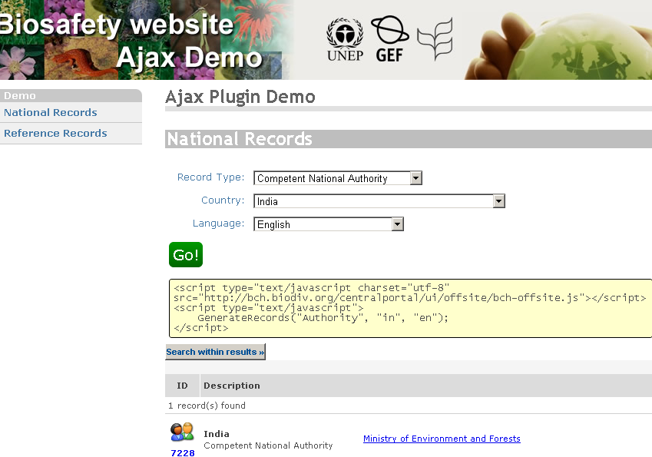

Figure 21 using the Ajax demo app to generate and run an Ajax script

Usage of wildcards and combined parameters.
The "documentType" and "country" parameters accept the usage of wildcards ("*" or "all"), and the possibility to specify more than one value (separated with comma ','
Please note that it is not possible to use wildcards simultaneously on "documentType" AND "country".
Examples:
- Focal Points and Authorities for Canada and United States in English:

<script type="text/javascript" charset="utf-8" >
GenerateRecords("focalPoint,authority", "ca,us", "en");
</script>

- Focal Points of all countries in Spanish:

<script type="text/javascript" charset="utf-8" >
GenerateRecords("focalPoint ", "*", "es");
</script>

- All records from United Kingdom in English:

<script type="text/javascript" charset="utf-8" >
GenerateRecords("* ", "uk", "en");
</script>

- All records from France, in French language:

<script type="text/javascript" charset="utf-8" >
GenerateRecords("* ", "fr", "fr");
</script>

- All BCH registered Risk Assessments, in English:

<script type="text/javascript" charset="utf-8" >
GenerateRecords (“riskAssessment", "*", "en ");
</script>

Search within results
Once the script has been executed and the results have been retrieved, the AJAX plugin offers a BCH Central Portal standard feature: “search within results”. See Figure 22.

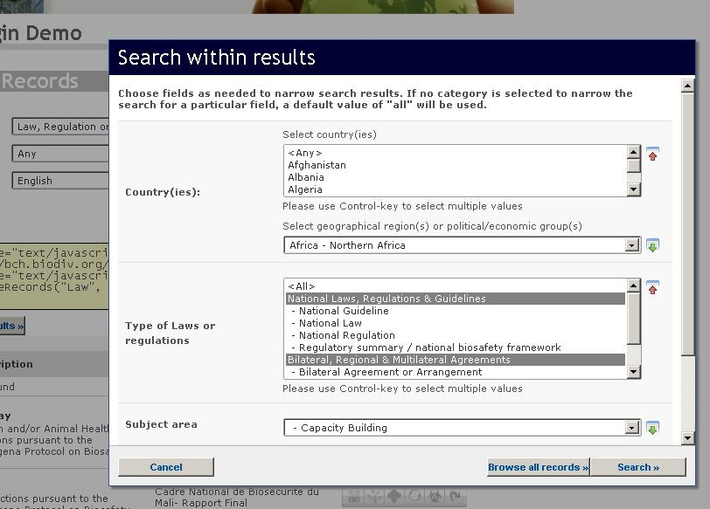
Figure 22 Search within results feature

Comments on searching reference records

Several types of reference records cannot be associated with a particular country. For these kinds of records, the country parameter shall be set to “*” (asterisk).

This applies to the following record types:

- birc | Biosafety Information Resource Centre
- organism | Organism Registry
- dnasequence | Gene and DNA Sequence Registry
- modifiedorganism | Living Modified Organism (LMO) Registry
- organization | Organizations involved in Biosafety Activities
- lmodetectionlaboratory | Laboratory for detection and identification of LMOs  (a subset of Organizations)

- ISO 3166 Country codes
Table 3 ISO 3166 two-letter country code.
Country names | ISO 3166-1-alpha-2 code
A
AFGHANISTAN | AF
ÅLAND ISLANDS | AX
ALBANIA | AL
ALGERIA | DZ
AMERICAN SAMOA | AS
ANDORRA | AD
ANGOLA | AO
ANGUILLA | AI
ANTARCTICA | AQ
ANTIGUA AND BARBUDA | AG
ARGENTINA | AR
ARMENIA | AM
ARUBA | AW
AUSTRALIA | AU
AUSTRIA | AT
AZERBAIJAN | AZ
B
BAHAMAS | BS
BAHRAIN | BH
BANGLADESH | BD
BARBADOS | BB
BELARUS | BY
BELGIUM | BE
BELIZE | BZ
BENIN | BJ
BERMUDA | BM
BHUTAN | BT
BOLIVIA | BO
BOSNIA AND HERZEGOVINA | BA
BOTSWANA | BW
Country names | ISO 3166-1-alpha-2 code
BOUVET ISLAND | BV
BRAZIL | BR
BRITISH INDIAN OCEAN TERRITORY | IO
BRUNEI DARUSSALAM | BN
BULGARIA | BG
BURKINA FASO | BF
BURUNDI | BI
C
CAMBODIA | KH
CAMEROON | CM
CANADA | CA
CAPE VERDE | CV
CAYMAN ISLANDS | KY
CENTRAL AFRICAN REPUBLIC | CF
CHAD | TD
CHILE | CL
CHINA | CN
CHRISTMAS ISLAND | CX
COCOS (KEELING) ISLANDS | CC
COLOMBIA | CO
COMOROS | KM
CONGO | CG
CONGO, THE DEMOCRATIC REPUBLIC OF THE | CD
COOK ISLANDS | CK
COSTA RICA | CR
CÔTE D'IVOIRE | CI
CROATIA | HR
CUBA | CU
CYPRUS | CY
CZECH REPUBLIC | CZ
D
DENMARK | DK
DJIBOUTI | DJ
DOMINICA | DM
Country names | ISO 3166-1-alpha-2 code
DOMINICAN REPUBLIC | DO
E
ECUADOR | EC
EGYPT | EG
EL SALVADOR | SV
EQUATORIAL GUINEA | GQ
ERITREA | ER
ESTONIA | EE
ETHIOPIA | ET
F
FALKLAND ISLANDS (MALVINAS) | FK
FAROE ISLANDS | FO
FIJI | FJ
FINLAND | FI
FRANCE | FR
FRENCH GUIANA | GF
FRENCH POLYNESIA | PF
FRENCH SOUTHERN TERRITORIES | TF
G
GABON | GA
GAMBIA | GM
GEORGIA | GE
GERMANY | DE
GHANA | GH
GIBRALTAR | GI
GREECE | GR
GREENLAND | GL
GRENADA | GD
GUADELOUPE | GP
GUAM | GU
GUATEMALA | GT
GUERNSEY | GG
GUINEA | GN
GUINEA-BISSAU | GW
Country names | ISO 3166-1-alpha-2 code
GUYANA | GY
H
HAITI | HT
HEARD ISLAND AND MCDONALD ISLANDS | HM
HOLY SEE (VATICAN CITY STATE) | VA
HONDURAS | HN
HONG KONG | HK
HUNGARY | HU
I
ICELAND | IS
INDIA | IN
INDONESIA | ID
IRAN, ISLAMIC REPUBLIC OF | IR
IRAQ | IQ
IRELAND | IE
ISLE OF MAN | IM
ISRAEL | IL
ITALY | IT
J
JAMAICA | JM
JAPAN | JP
JERSEY | JE
JORDAN | JO
K
KAZAKHSTAN | KZ
KENYA | KE
KIRIBATI | KI
KOREA, DEMOCRATIC PEOPLE'S REPUBLIC OF | KP
KOREA, REPUBLIC OF | KR
KUWAIT | KW
KYRGYZSTAN | KG
L
LAO PEOPLE'S DEMOCRATIC REPUBLIC | LA
LATVIA | LV
Country names | ISO 3166-1-alpha-2 code
LEBANON | LB
LESOTHO | LS
LIBERIA | LR
LIBYAN ARAB JAMAHIRIYA | LY
LIECHTENSTEIN | LI
LITHUANIA | LT
LUXEMBOURG | LU
M
MACAO | MO
MACEDONIA, THE FORMER YUGOSLAV REPUBLIC OF | MK
MADAGASCAR | MG
MALAWI | MW
MALAYSIA | MY
MALDIVES | MV
MALI | ML
MALTA | MT
MARSHALL ISLANDS | MH
MARTINIQUE | MQ
MAURITANIA | MR
MAURITIUS | MU
MAYOTTE | YT
MEXICO | MX
MICRONESIA, FEDERATED STATES OF | FM
MOLDOVA, REPUBLIC OF | MD
MONACO | MC
MONGOLIA | MN
MONTENEGRO | ME
MONTSERRAT | MS
MOROCCO | MA
MOZAMBIQUE | MZ
MYANMAR | MM
N
NAMIBIA | NA
NAURU | NR
Country names | ISO 3166-1-alpha-2 code
NEPAL | NP
NETHERLANDS | NL
NETHERLANDS ANTILLES | AN
NEW CALEDONIA | NC
NEW ZEALAND | NZ
NICARAGUA | NI
NIGER | NE
NIGERIA | NG
NIUE | NU
NORFOLK ISLAND | NF
NORTHERN MARIANA ISLANDS | MP
NORWAY | NO
O
OMAN | OM
P
PAKISTAN | PK
PALAU | PW
PALESTINIAN TERRITORY, OCCUPIED | PS
PANAMA | PA
PAPUA NEW GUINEA | PG
PARAGUAY | PY
PERU | PE
PHILIPPINES | PH
PITCAIRN | PN
POLAND | PL
PORTUGAL | PT
PUERTO RICO | PR
Q
QATAR | QA
R
RÉUNION | RE
ROMANIA | RO
RUSSIAN FEDERATION | RU
RWANDA | RW
Country names | ISO 3166-1-alpha-2 code
S
SAINT BARTHÉLEMY | BL
SAINT HELENA | SH
SAINT KITTS AND NEVIS | KN
SAINT LUCIA | LC
SAINT MARTIN | MF
SAINT PIERRE AND MIQUELON | PM
SAINT VINCENT AND THE GRENADINES | VC
SAMOA | WS
SAN MARINO | SM
SAO TOME AND PRINCIPE | ST
SAUDI ARABIA | SA
SENEGAL | SN
SERBIA | RS
SEYCHELLES | SC
SIERRA LEONE | SL
SINGAPORE | SG
SLOVAKIA | SK
SLOVENIA | SI
SOLOMON ISLANDS | SB
SOMALIA | SO
SOUTH AFRICA | ZA
SOUTH GEORGIA AND THE SOUTH SANDWICH ISLANDS | GS
SPAIN | ES
SRI LANKA | LK
SUDAN | SD
SURINAME | SR
SVALBARD AND JAN MAYEN | SJ
SWAZILAND | SZ
SWEDEN | SE
SWITZERLAND | CH
SYRIAN ARAB REPUBLIC | SY
Country names | ISO 3166-1-alpha-2 code
T
TAIWAN, PROVINCE OF CHINA | TW
TAJIKISTAN | TJ
TANZANIA, UNITED REPUBLIC OF | TZ
THAILAND | TH
TIMOR-LESTE | TL
TOGO | TG
TOKELAU | TK
TONGA | TO
TRINIDAD AND TOBAGO | TT
TUNISIA | TN
TURKEY | TR
TURKMENISTAN | TM
TURKS AND CAICOS ISLANDS | TC
TUVALU | TV
U
UGANDA | UG
UKRAINE | UA
UNITED ARAB EMIRATES | AE
UNITED KINGDOM | GB
UNITED STATES | US
UNITED STATES MINOR OUTLYING ISLANDS | UM
URUGUAY | UY
UZBEKISTAN | UZ
V
VANUATU | VU
VATICAN CITY STATE | see HOLY SEE
VENEZUELA | VE
VIET NAM | VN
VIRGIN ISLANDS, BRITISH | VG
VIRGIN ISLANDS, U.S. | VI
W
WALLIS AND FUTUNA | WF
WESTERN SAHARA | EH
Country names | ISO 3166-1-alpha-2 code
Y
YEMEN | YE
Z
ZAIRE | see CONGO, THE DEMOCRATIC REPUBLIC OF THE
ZAMBIA | ZM
ZIMBABWE | ZW

